JAGAT J L

Module 1 - Data structures and Algorithms
Exercise – 01
Data structures and Algorithms
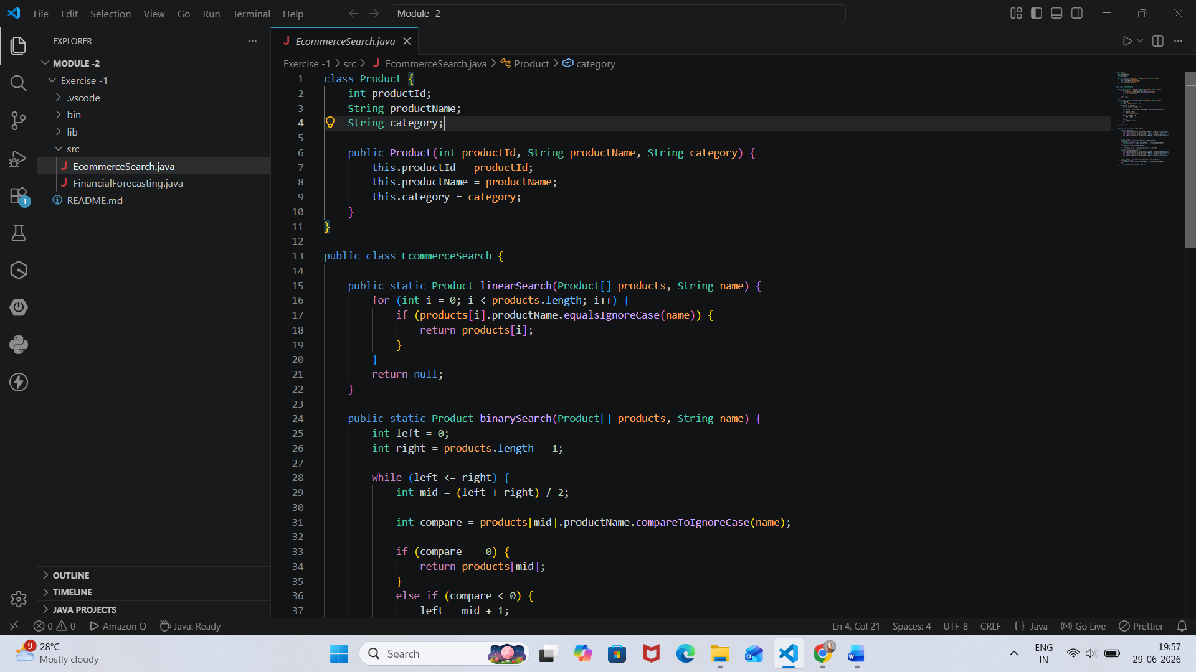
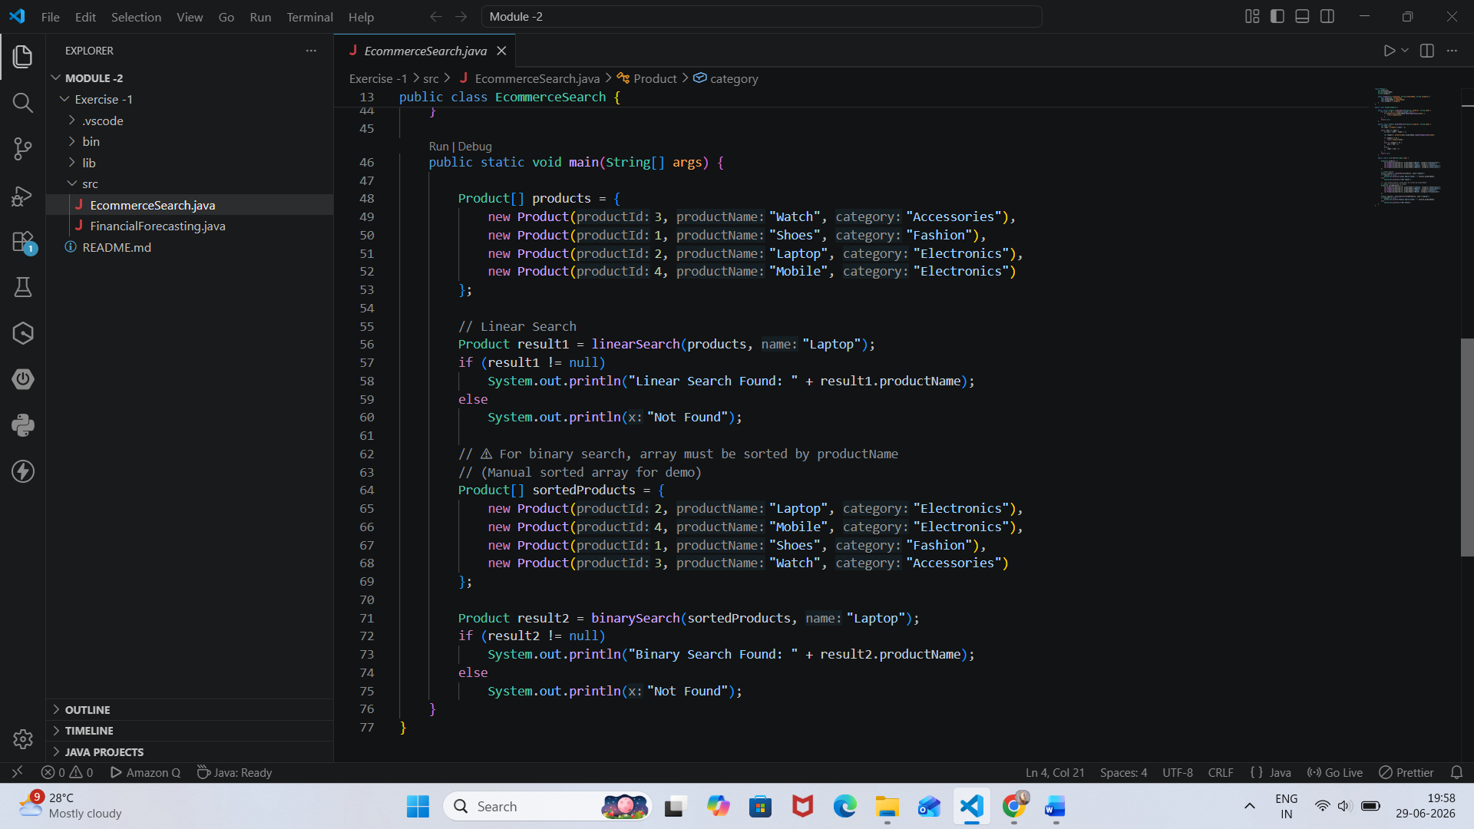

Output:
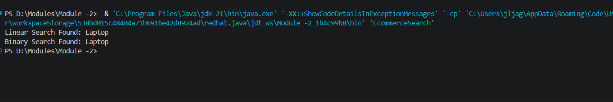

Complexity Analysis
Algorithm | Best Case | Average Case | Worst Case
Linear Search | O(1) | O(n) | O(n)
Binary Search | O(1) | O(log n) | O(log n)

Conclusion
- Linear Search is simple but inefficient for large datasets.
- Binary Search is significantly faster but requires sorted data.
- For real-world e-commerce systems, advanced indexing and search engines are preferred for scalability.

